**TimelapseBuild V2**

**Idea:**

3-Axis Movement-kit for my DSLM.

A- 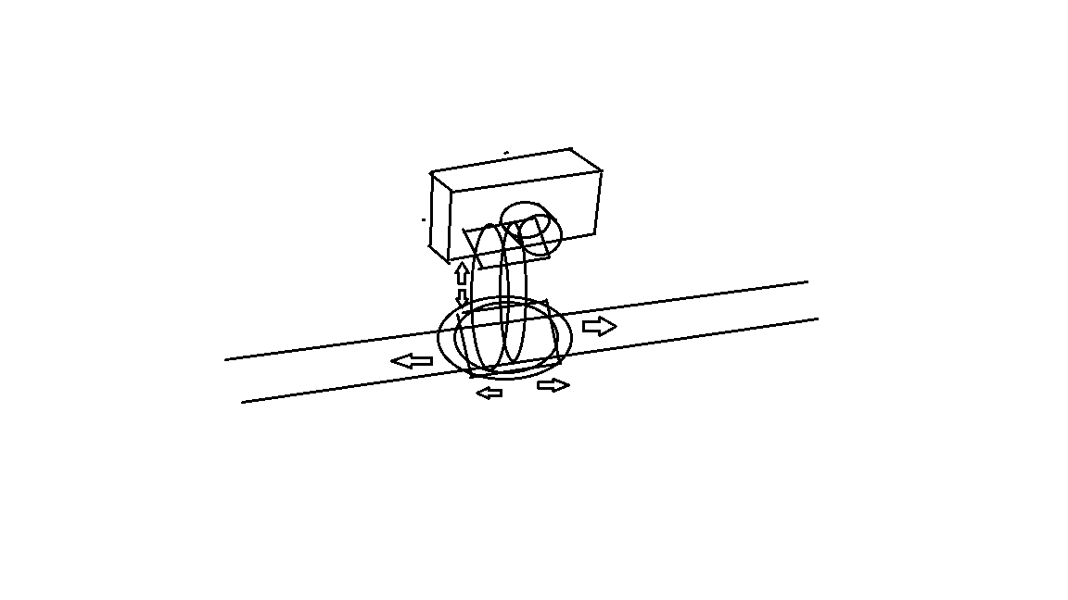and B-Axis for Pitch and Jaw. X-Axis for Horizontal Movement on a Slider.

**Coarse Requirements and Implementation:**

All Axis are driven by Stepper-Motors. The A-,B-Axis have an Absolute Encoder to set the position by moving the Camera manually. The X-Axis will get also an Absolute Encoder with sensorless Endstop Control by the Trynamic TMC2130 Stepper Trivers with the „Stall Detection“. The Absolute Encoder ist for Setting the Position by moving the Slider.

The main Controll will be some STM32. The physical Interface will consist of an 3.5 Touchscreen and 2 analog-Joysticks. As an addition for wireless Controll, the STM32 will communicate with an ESP32 for WiFi and Bluetooth Connection to an Android Device via App, or WiFi-Device via WebSite.

A-Motor: Nema17 0.9deg 42x42x20 ~ 11Ncm(Hold Torque)

B-Motor: Nema17 0.9deg 42x42x39 ~ 36Ncm(Hold Torque)

X-Motor: Nema17 0.9deg 42x42x??

The A- and B-motors drive the corresponding axis with a 1:4 gear Reduction. The Transmission is applyed over Loop-Belts.

The Path of the motion is difined by the programmed points. The path will be by user selction iterpolated linear or by a grad 3 spline for each axis.

More Options: get Positon and Time manually or

* Over the remote Device

Star(Milkyway), Moon and Sun tracker(1 and 2 Axis)